**CrypToolStore – “general ideas” - whitepaper**

Nils Kopal, 2018-07-24

The **CrypToolStore** consists of five main components:

* **1) CrypToolStoreDatabase** MySQL database containing “everything”
* **2) CrypToolStoreBuildSystem** Automatic system for building components
* **3) CrypToolStoreDeveloperClient** Client to upload and create user account etc.
* **4) CrypToolStoreServer** Server to allow upload, download, etc.
* **5) CrypToolStoreUserClient** Client in CrypTool2 for downloading components

Architecture overview (clouds are connection over Internet, i.e. have to be secured):

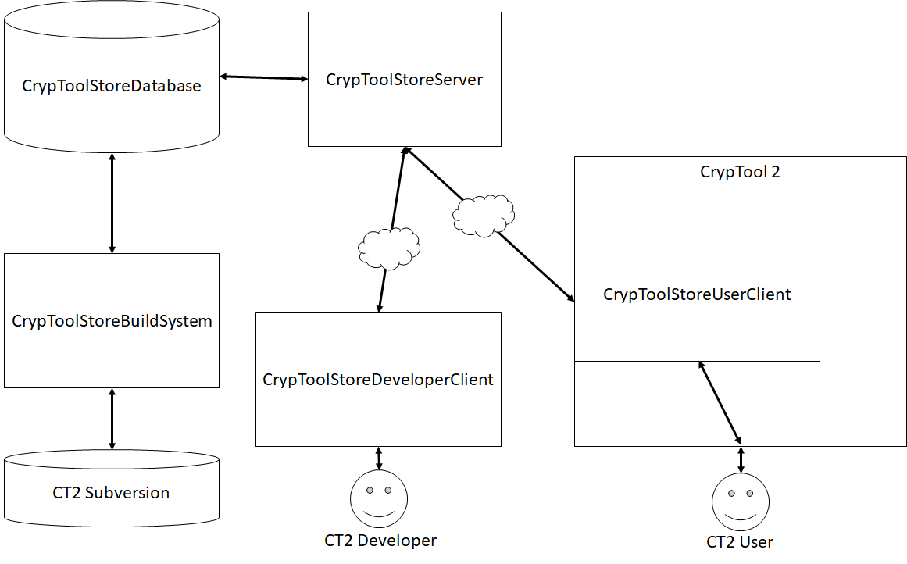

**1) CrypToolStoreDatabase**

The CrypToolStoreDatabase is a (MySQL or another relational dbs) database containing:

* Developer user credentials
* Store components source code
* Downloadable store components
* Downloadable additional resources (i.e. “huge” language statistics files)

**2) CrypToolStoreBuildSystem**

The CrypToolStoreBuildSystem automatically detects, if there is a new upload of a CrypToolStoreComponent. If yes, it will automatically download its source code, build the corresponding CrypPlugin and upload the binary to the database.

All downloadable assemblies will be signed using the official CrypTool 2 code-signing certificate. This is needed since CrypTool 2 won’t load non-signed assemblies.

First idea of folder structure for build system:

CrypToolStoreBuildSystem <- main folder

CrypToolStoreBuildSystem/CrypToolStorePlugins <- folder for store plugins

CrypToolStoreBuildSystem /libs <- needed libraries of CT2 for building plugins

**3) CrypToolStoreDeveloperClient**

The developer client has to be used to upload store components (source code). The source code has to be uploaded as a single zip-file containing everything needed for building the CrypPlugin. Furthermore, only references to libraries of CrypTool 2 folders libsource and libdev are allowed. Additionally, CrypCore and CrypPluginBase are referenced, since these are needed by every CrypPlugin. The client will also give feedback, if the “online” build was successful or erroneous. Each upload of a CrypToolStoreComponent will generate a new version, starting at version 1. The “active” version has to be set by the uploader. Only CrypToolStoreComponents in state “success” are allowed to be set active.

Concerning downloadable resources: The client will also allow to upload files that can be downloaded by CrypTool 2 and used inside CrypTool 2. Uploaded files will also get a version and an active state.

**4) CrypToolStoreServer**

The server is the connection between the clients and the database. It will allow to upload and download. Communication will be secured using TLS.

**5) CrypToolStoreUserClient**

The CrypToolStoreClient is a new “editor” inside CrypTool 2. It allows to view and download as well as delete CrypToolStoreComponentes. CrypToolStoreComponents are located in %APPDATA%\Local\CrypTool2\CrypToolStorePlugins (have to rename it from CrypStorePlugins to CrypToolStorePlugins). Additionaly resources are located in %APPDATA%\Local\CrypTool2\CrypToolStoreResources

The client will always show the active version of a component / resource. If the active version changes, it automatically updates the component at startup of CrypTool 2 to the current version. To do so, it will first delete the plugins folder. Then, it will download the active version.

To maintain versions of downloaded CrypStorePlugins, the client will have a single xml for every downloaded CrypStorePlugin. Same applies to downloaded resource files.